CHRISTIANS & ACCOUNTABILITY - Part 2
This week I'd like to continue the behaviour conversation but in a more positive manner. I do this because it's easy to jump on the bandwagon when high-profile Christians fail. It would be wrong to only sound the siren when Christian unfaithfulness is publicly exposed.

It's time to raise the profile of those people who quietly and humbly fight the good fight, resist sin and live godly lives. They are the examples we need to know about.

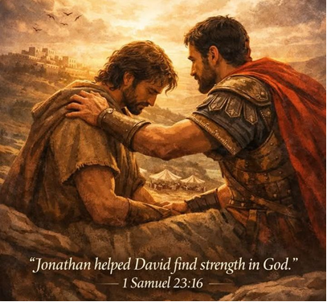
King Solomon wrote about the importance of having people who would help shape us. He used the metaphor, 'As iron sharpens iron, so one man sharpens another.' His teaching illustration was to encourage men to 'file' each other so they could have a sharper character. He indicates that good men will improve each other and together they will become wiser and better. Few men can go it alone and be successful with their life.
When the young warrior David was downcast, wondering where his life was going, his best friend Jonathan came to him to lift his focus. 1 Samuel 23:16 records it, saying, 'And Saul's son Jonathan went to David at Horesh and helped him find strength in God.'

I'm moved by the significant wisdom and strength that Jonathan gave David at one of his lowest points. We all need friends like that. They are people who help guide, warn, lift and encourage us. And importantly, they keep us accountable to our Christian values.

My first Rally leader was a Jonathan to me. After I became a Christian, my home situation was challenging. Once a week, every Rally night, I was encouraged to have faith in God. Rubbing shoulders with my Rally leaders helped and inspired me to stand tall as a young Christian.

Moving to Oamaru placed me in another positive environment with the Christians at the then Stewards Street Gospel Hall. In time, the name and location of the church changed, but my friendships and fellowship with a good number of young and older men were exactly what I needed. Their examples stimulated my desire to know more about the Lord and how to live the Christian life. I'm humbled to tell you that in the midst of my cancer diagnosis, their Jonathan-like prayers and presence helped me through that ordeal. In the years that followed, their light fanned my weak light until it grew brighter.

When Wanda and I entered full-time ministry in 1986, we were blessed to have a team come around us. We met regularly with the desire to grow the impact of the Gospel, but just as importantly, they were intentional about protecting and supporting us as we learned the disciplines of ministry. I'm grateful for the years of wisdom, guidance, warnings and prayer they gave us. I'm the first to admit that without their Jonathan like strength, many times my young headstrong attitude, stupidity or impetuous reactions could have been my undoing.

Surrounding me with a culture of accountability, they established boundaries, set standards and asked the searching questions. We all understood the risks of being undisciplined with money, morals and an inflated ego. For almost 40 years, their watch over my finances, conduct, and conversations provided a wall of discretion around my heart, my family and my ministry. I honour them today. Their diligence and their love for protecting my marriage and family helped me find strength in God. I owe them so much. Like Jonathan, their behind-the-scenes friendship made such a difference.
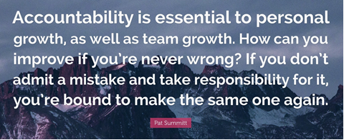
An American survey in 2021, discovered the unnerving truth that many men did not have a best friend, lacked authenticity, had zero accountability, had no emotional support and were lonely.
Source: May American Perspectives Survey.
https://gaministry.us19.list-manage.com/track/click?u=787f5fdcd16b58f49f3335b9b&id=87e445603c&e=7a0c9b6673

A good number of men have admitted to me that they have many acquaintances but few close friends. This concerns me because in the Christian church there should be many bands of brothers. I'm the first to acknowledge that women have more friends than men. They appear to value social interactions and meaningful time together more than men do. It's time we recognised that accountability is a good thing. Quality friendships with significant others can stimulate Christian development. I like how an American attorney and politician said it . . .
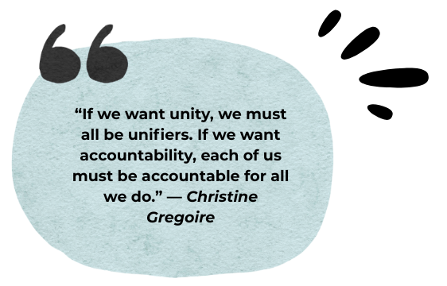
In light of the tragic indiscretions by well-known Christian leaders, it's time we salute the men and women among us who diligently serve among their faith communities. Their names may never be in lights because they prefer the quiet, low profile positions where they are authentic examples of servant leaders. I believe these genuine believers will be the first to be rewarded for their good works.

Every week, and often daily, they help people find strength in God through their visitation, their phone or text calls, their encouraging emails, their grace-filled
words, and their acts of service. These wonderful people pray, serve and love all those whom God has given them. They are the embodiment of Jonathan of old. We need more of them.


