WHEN CHRISTIANS FALL – Part One
In early January, Christians around the world were shocked to learn of the full withdrawal from ministry by author Philip Yancey, who confessed to having an eight-year affair.
The headlines and articles that followed were sad reading, as we learned more details of how such an influential and well-respected leader had succumbed to sin and that his ministry was now over.

Most commentators agree that many variables contribute to the disgrace that brings a Christian down. In every case, there will be contributing factors, but ultimately, Scripture gives a direct answer: 'Sin.'
God's insights are confronting,
'...sin is crouching at your door; it desires to have you, but you must rule over it' (Genesis 4:7)
'It is your sin that separates you from God' (Isaiah 59:2).
'The heart is deceitful above all things and beyond cure. Who can understand it?' (Jeremiah 17:9).
When moral failure happens in the Christian community it’s difficult to comprehend.
When I began full-time ministry in 1986, news broke about Jimmy Swaggart, a well-known American Television Evangelist who was publicly exposed for inappropriate conduct with prostitutes. I was 29 then, and the revelation left me feeling unsettled as I grappled with my own expectations and responsibilities as a leader.
Soon after, I met the leader of a significant New Zealand denomination on a domestic flight. We had an uplifting conversation and swapped books. He gave me Ordering Your Private World by Gordon MacDonald, which taught me valuable lessons about inner discipline.
A year later, I learned that Gordon MacDonald had resigned from the ministry because of an affair. Much later, I was stunned to discover that the same man who gave me Ordering Your Private World was repeatedly unfaithful during his ministry.
From that time on, I kept a list of names of recognised Christian leaders who had surrendered to sin. In the years that followed, I added more and more names to that list. Some of those names stabbed at my heart because they were friends I had once respected and worked beside. Twenty years later, I burned that list. The names on it were depressing and undermined the hope that I had for the Christian movement I worked with. I’m glad I can’t remember all the names; nevertheless, their agony remains a warning to me to stay constantly vigilant in both my public and private life.
For many years, around the world, a catalogue of prominent names, too numerous to list, have lined the hall of shame. More recently, the sins of other popular Christian speakers, entertainers, writers and pastors have surfaced, exposing their ungodly behaviour. It’s disheartening to see acclaimed leaders like Gordon McDonald, Bill Gothard, Bill Hybels, Ravi Zacharias, Brian Houston, Carl Lentz, Michael Tait and Shaun Bolz crash and burn.
Publicly, it appeared their front door was locked with solid principles, but tragically, their back door was wide open to sin. Like a grenade exploding without warning, their infidelity inflicts deep emotional wounds, leaving many struggling to heal.
What hurts the most is that these are people we expected to show the highest level of integrity. Millions trusted their words, songs, insights, and wisdom. They were lights in the darkness, and although we never met them personally, they helped guide and grow our own faith.
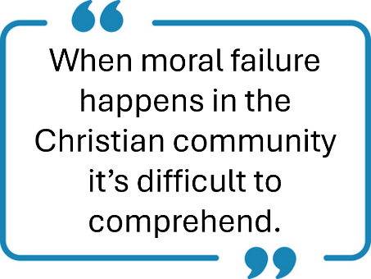
When a Christians behaviour is compromised, and they squander their ministries because of adultery, we all feel the pain. And by no means are we but a few. Around the world, families, churches, friends, workmates and many others are shattered when hypocritical leaders are uncovered. With every tragedy of this kind, the church and Christianity lose credibility. The confusing contradiction arises when leaders say they believe in God’s way but behave with man’s way. Hypocrisy stings us all when the truth is discovered. The grief is real, and the scars remain.
I’m not judging these people; that's the Lord’s prerogative. God’s Word is clear; all men will stand before His throne one day (2 Corinthians 5:10).
I hesitated to write this article, fearful of how easily my own marriage and family could become a target. Yet I engage because too often we are not warned about how vulnerable we all are to harmful behaviours—and how devastating the consequences can be when we fail to trust God’s way by guarding our hearts (Proverbs 4:23).

Over the last forty years, I’ve watched countless individuals rise in ministry only to later be disqualified. While each scandal still comes as a shock, looking back reveals a disturbingly consistent pattern among those who fall.
- None were involved with real accountability.
- They defied the Word of God – their behaviour did not match their belief.
- They spent significant time with another woman.
- All believed, ‘It would never happen to me.’
- Wedding vows were forgotten.
- Every one of them took their eyes off the Lord.
Statistics from Church Leadership organisation in the USA report:
Of the one thousand fifty (1,050 or 100%) pastors, we surveyed, every one of them had a close associate or seminary buddy who had left the ministry because of burnout, conflict in their church, or from a moral failure.
Three hundred fifteen (315 or 30%) said they had either been in an ongoing affair or a one-time sexual encounter with a parishioner.
Source - ChurchLeadership.org
http://www.churchleadership.org/apps/articles/default.asp?articleid=42347

We have no statistical database here in New Zealand, but moral failure among Christians have been a disappointing thread throughout our history.
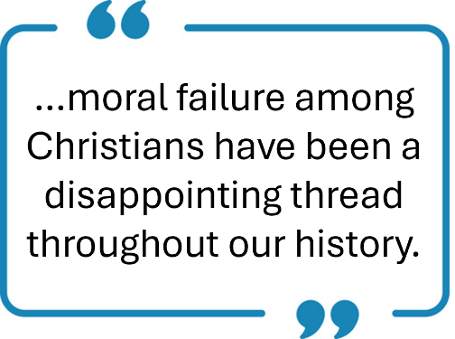
This is a crisis we cannot stay silent about. The danger is not limited to pastors and authors. Builders and plumbers, directors and trustees, stay-at-home mums, computer geeks and students—every person who longs to follow Christ—is being targeted by our great enemy, who prowls like a roaring lion, seeking to devour (1 Peter 5:8).
In a world that accepts immorality, nakedness, flirting behaviour, lusts and out-of-control behaviour, more lives will be devastated. This should compel every Christian to seek purity, humility and accountability. Our eyes must remain on Jesus, the author and perfector of our faith (Hebrews 12:2).

If you've never done so, get on your knees right now and seek the Lord's face and ask for divine protection. Make a fresh commitment . . .
- To protect yourself, your family, your relationships and your future,
- Find someone who will be honest with you and keep you accountable.
- Trust and obey God’s Word. Let Bible truths shape your behaviour.
- Spend significant time with God. He will never let you down.
- Believe, sin is never far from your heart's door. Choose to walk in God’s light.
- Renew your wedding vows.
- Determine to keep your eyes glued to the Lord Jesus Christ.

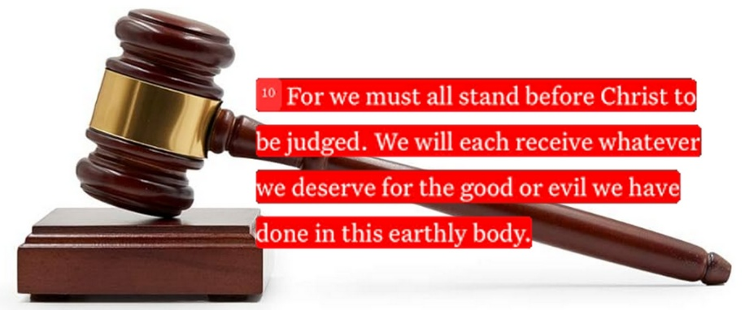
Let's pray for one another, that we will be able to stand against the fiery darts of our enemy.
Purity, humility and accountability should be prominent characteristics for all Christians. Pray especially for those in leadership roles. They are big targets and the greater their responsibilities are, the greater the fall.
Be encouraged.
Blessings
Graham & Wanda
February 9, 2026

